CCTV

CCTV cameras are used in every shop, park and cafe you can find, there are an estimated 1.9 million cameras in the U.K. which is one camera for every 32 people. They can watch every step you take. Some people think thet this helps to keep everyone safe and to find people that are wanted. Others would say that it is an invasion of their privacy and no where should be allowed to ‘spy’ on us.

I think that it is an invasion of peoples privacy because they are all over and there are no clear rules. So nobody knows when shops have cameras in illegal places and if they are keeping the footage or deleting it or maybe selling it on to other places. This can sometimes result in good things like a criminal being found.

This relates to Computer Science because it relates to the Computer Ethics part of it which is “a part of practical philosophy which concerns with how computing professionals should make decisions regarding professional and social conduct.” This is basically the rules that people should follow when they are using a computer and especially online.

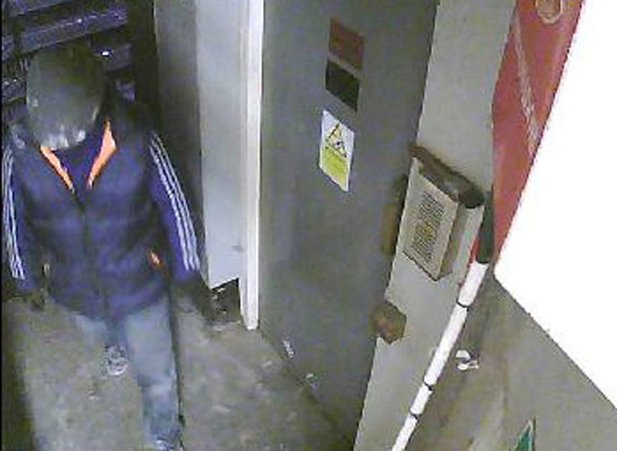The good side of the argument is that 7 out of 10 of the crimes that are investigated by the police are caught on camera. One of the most famous crimes that was caught on CCTV in the last few years is the Hatton Garden Heist. The robbers were all caught on CCTV and arrested within 5 days of stealing the money.

The law, The Surveillance Camera Code of Practice, says “An individual can expect to be the subject of surveillance in a public place as CCTV, for example, is a familiar feature in places that the public frequent. An individual can, however, rightly expect surveillance in public places to be both necessary and proportionate, with appropriate safeguards in place.” This means that if you are out in public then you should expect to be filmed by CCTV the whole time but you should also be able to rely on the camers owners to use the footage with a good intention and delete it after they have finished.

By Felix 10P